**FANAS**

**Proof of concept**

**Version 1.1**

# **Revision History**

| **Date** | **Version** | **Description** | **Author** |
| --- | --- | --- | --- |
| 24/05/2024 | 1.0 | Proof of concept | Nguyễn Phước Thịnh |
| 04/06/2024 | 1.1 | Editing Document | Nguyễn Phước Thịnh |

# Proof

* **Input**: A book audio file

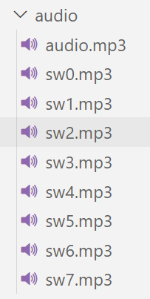

* **Output**: An audio for that chapter with playback control

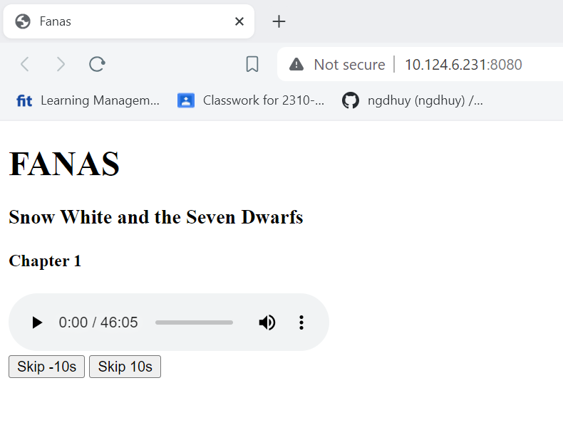

# Source code

* app.js:

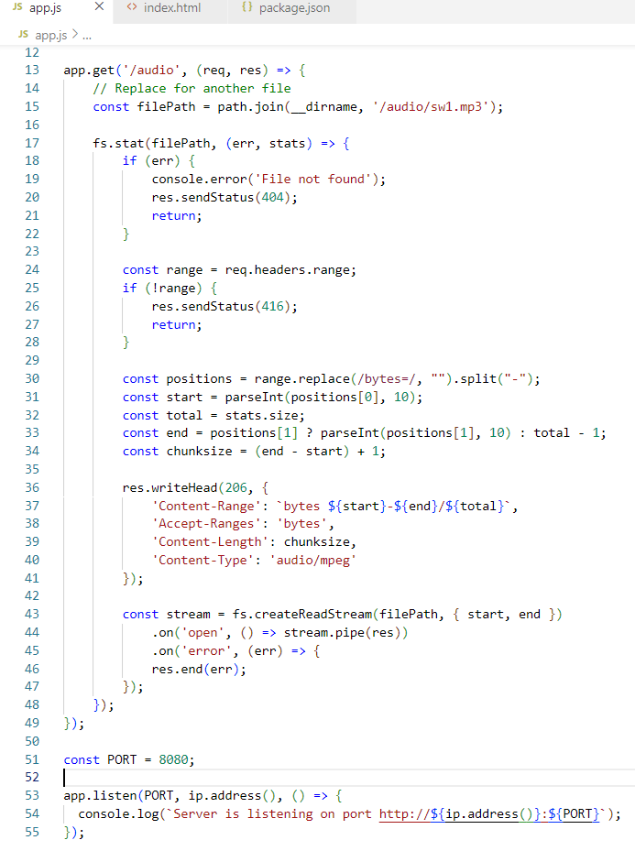

* index.html:

